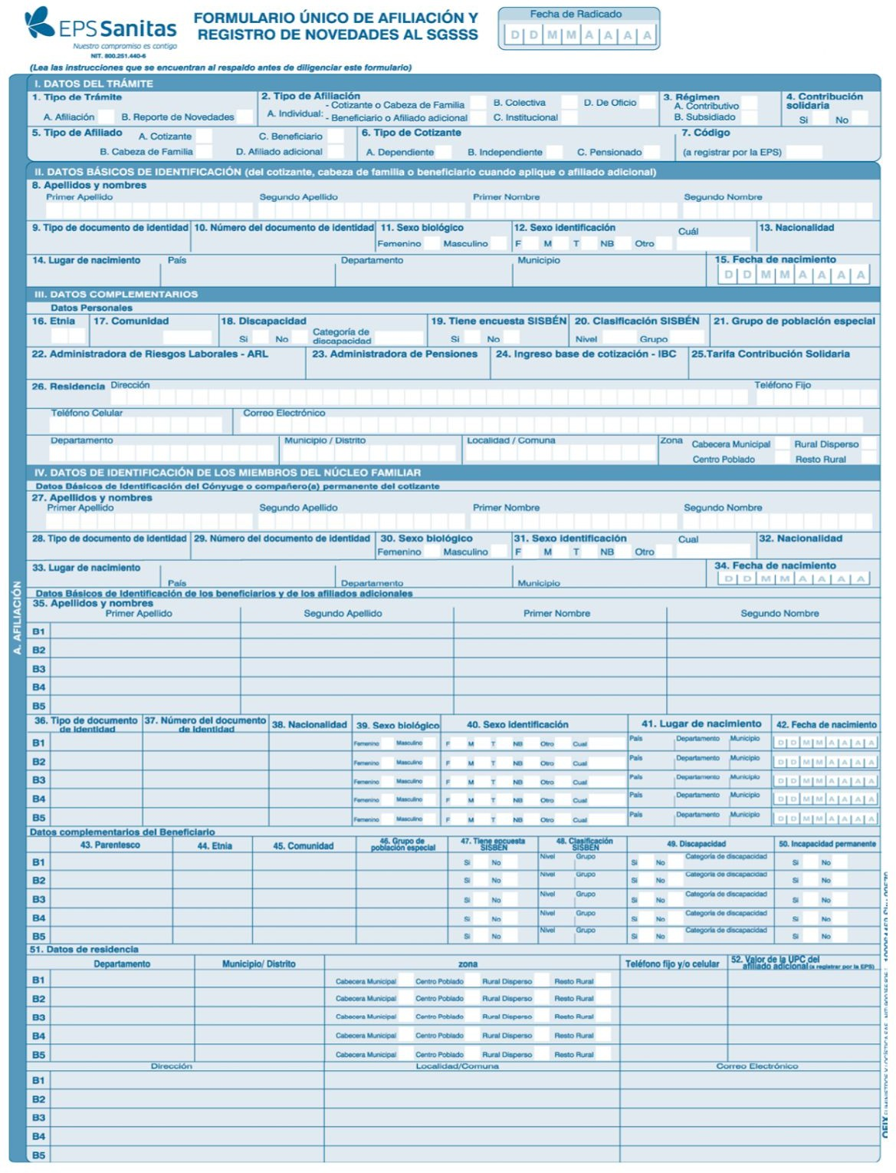

F I G U E R E D O E C H E V E R R Y D I E G O S T I V E N

CC 1032939966 COLOMBIANA

BOGOTÁ D.C COLOMBIA CUNDINAMARCA BOGOTÁ D.C 2 9 0 9 2 0 0 6

SURA COLPENSIONES 1.720.000

D I A G O N A L 1 4 6 N ° 1 3 6 A - 5 9

3 0 1 3 0 8 1 6 6 6 f i g u e r e d o 1 1 0 1 @ g m a i l . c o m

C U N D I N A M A R C A B O G O T Á S U B A

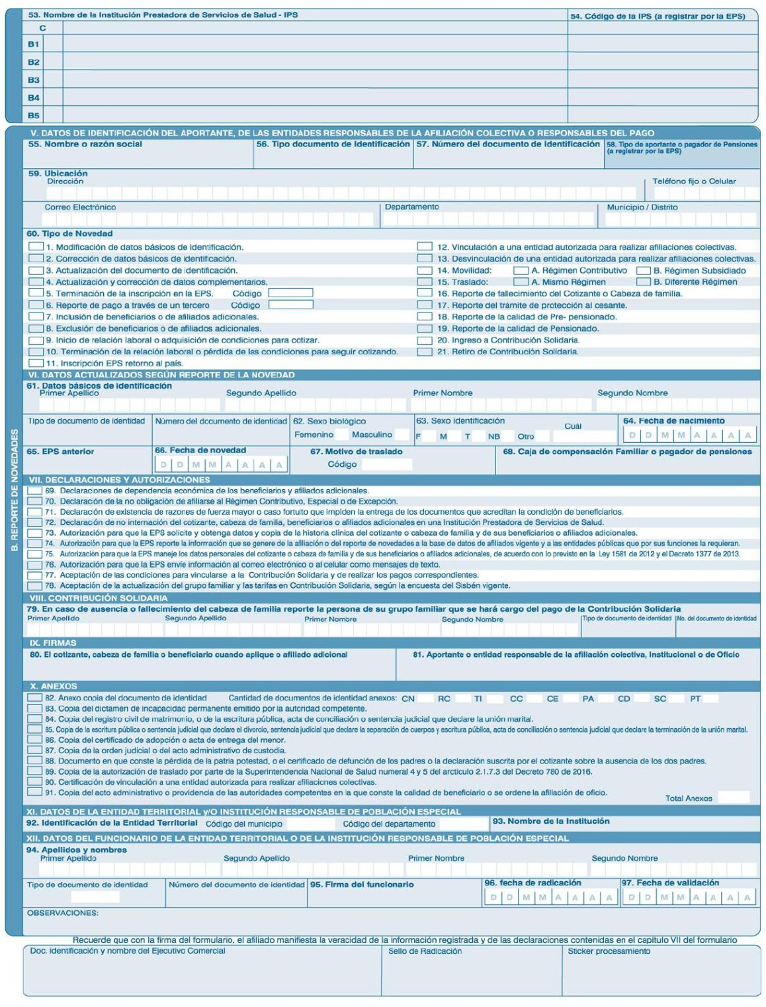

G. Herrera & Asociados Abogados S.a.s. NIT 900701533

|  |  |  |  |  |  |
| --- | --- | --- | --- | --- | --- |
| A V 6 A B I S # 3 5 | N 1 0 0 |  |  |  | 6026594075 |
| g h e r r e r a @ g | h a . c o m . c o | V A L | L E | C A L I |  |

F I G U E R E D O E C H E V E R R Y D I E G O S T I V E N

CC 1032939966 2 9 0 9 2 0 0 6

1 8 0 7 2 0 2 5 COLPENSIONES